Identify Source Over/Under

Bank Reconciliation cross checks to verify all transactions on the bank statement are accounted for on the Bank Reconciliation screen:
- Bank Side: Cleared Deposits plus any direct deposit transfers (payroll, etc.) equals Bank Statement Credits
- Bank Side: Cleared Checks plus any transfers (not entered with Transfer Transaction Processing) and journals to credit cash on the books equals Bank Statement Debits.
- If Unreconciled Difference is a negative (-) the bank has more than the books.
- If Unreconciled Difference is a positive (+) the books have more cash than the bank.

System Cash Verification – recommended to always begin the reconciliation with a verification the system cash is accurate using a summary general ledger inquiry of the cash accounts. Calculate the “bank” cash amount from the summary and verify it matches the System Cash on the Bank Reconciliation. If not, the bank account fund group tables need to be updated to reflect the correct System Cash.

REASONS FOR DIFFERENCES- places to look

- Transposition error- is the difference divisible by 9? If so, check your amounts because there may be a number transposed (digits in the wrong order- 76 not 67)
Add the digits together to see if it is divisible by 9- ex. 576 = 5+7+6=18
- Cash Inquiry items- are there any items listed that have not been accounted for?

- Outstanding / Unposted checks- did you miss a check or transpose the amount when entering it?

- Deposits / Unposted in transit- did you miss a deposit or transpose the amount?

- Bank charges- did you list charges that are on the bank statement but not posted on the book side? Bank charges and interest should be entered as District Written checks, Cash Receipts or Journal Actual entries.

- Voids or Reissues- are there any voided checks not entered in the system or did they clear anyway? Were all Voids/Reissue interfaced?

- Journal entries- were there any JV entries to the cash account on the books that do not match the bank statement? Look at the Journal Inquiry – JV Type: Actual - enter the From Date and the To Date – Acct Period.

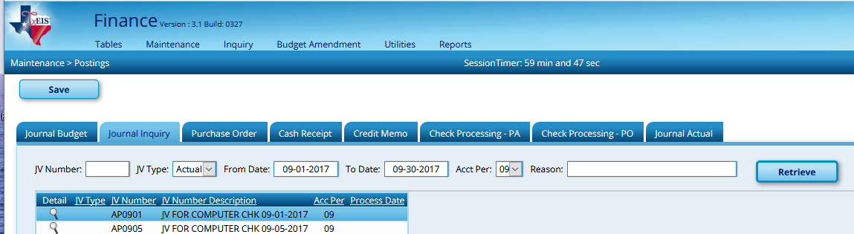

- Wrong ‘Balance per General Ledger’- be sure you have correct cash balances for each fund that goes to this bank account and that you are not including funds that belong to other bank accounts.

- Check your detail general ledger beginning month balances to verify they match your last month’s reconciliation. If the gen. ledger beginning month balance does not equal your last month’s bank rec spreadsheet beginning book balance, then entries were made to cash in the previous month after you completed the reconciliation. Take these amounts into consideration for this month’s statement.

- Do your total checks on your check register equal the withdrawal total on the bank statement? Do your cash receipt journal totals equal the deposit total on the bank statement? If either answers are NO, then recheck that side to see what was missed.

- Were there outstanding adjustments the previous month? If so, were those accounted for this month or are they still outstanding

**** Note: Cash General Ledger Balance can be affected by auditor’s adjusting entries. Be sure you are using the correct balances and be aware that auditor’s adjusting entries can cause you not to balance. Auditor’s entries do not always balance--even though they should. You also may need to take off items from your spreadsheet that the auditor included in their adjusted cash balance.

- If you enter Cash Receipts, Checks, or Journal Entries after the bank reconciliation has been created, transactions must be re-pulled from reconciliation to be up to date.

TxEIS Specific Reminders…

Finance
***Cash receipts and checks are automatically posted to cash when saved - check numbers are assigned when printed and posted.

Payroll
*** If auto JV payroll transactions are selected, then the system will post net payroll check amounts to clearing fund.

***Statutory Minimum, Non-OASDI and the Child Nutrition amounts of the TRS 3 and 489 are interface. Expense is posted when the RP is interfaces. Payment should be recorded as a district written check or use Transfer Transaction Processing.

***Example include
- Taxes
- Active Care Bill
- TRS TexNet amounts
- Child Support (if wired)
- Any other payments made on-line.

TexNet Description | Payroll Clearing Accounts
Member Contribution Amount | 2155.00
Member TRS-Care Contribution Amount | 2155.00
RE Federal Funds/Private Grant Contribution Amount | 2155.01
RE Statutory Minimum Contribution Amount | 2155.02
RE Federal Fund/Private Grant TRS-Care Contribution Amount | 2155.03
SSBB Deduction - TRS 565  (This is TRS Buy Back) | 2159.00-XXX  (XXX = deduction codes)
TRS Active Care Billed Amount Due | 2153.00-XXX  (XXX = deduction codes)
RE TRS-Care Contribution Amount | 2155.04
RE New Members Contribution Amount | 2155.05
RE Pension Surcharge for Retirees | 2155.06
RE TRS-Care Surcharge for Retirees | 2155.07
Non-OASDI Member Contribution Amount | 2155.08

